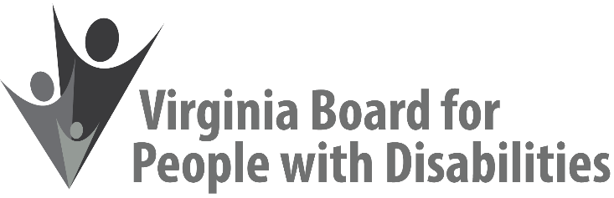
AGENDA

Date: November 16, 2021

Time: 10:00 a.m. – 12:30 p.m.

Zoom: Click here to join Zoom meeting
Meeting ID: 824 0635 7096
Passcode: 255015
Dial by Location: 1 301 715 8592 US (Washington DC)

Cultural and Linguistic Competence Training
This meeting is being held solely to receive a presentations. The Board will not take any votes or make any formal recommendations.

10:00 to 12:30 Introduction to Cultural and Linguistic Competence, Dr. Vivian Jackson and Ms. Marisa Brown

